You will receive an email notification saying, “A review has been submitted to you”. There are two ways you can access this review.
The first way is by clicking on the highlighted blue words in the email, you can click on either “Proliant” or “Inbox”, both will take you to the review.
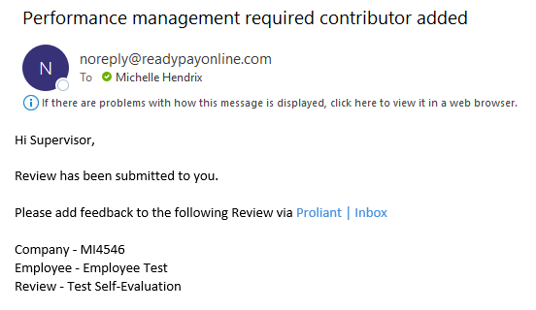
The second way you can access this review would be to log into your account and you will see a bell with a notification on it you can click the bell and click on reviews that way and it will take you to it.
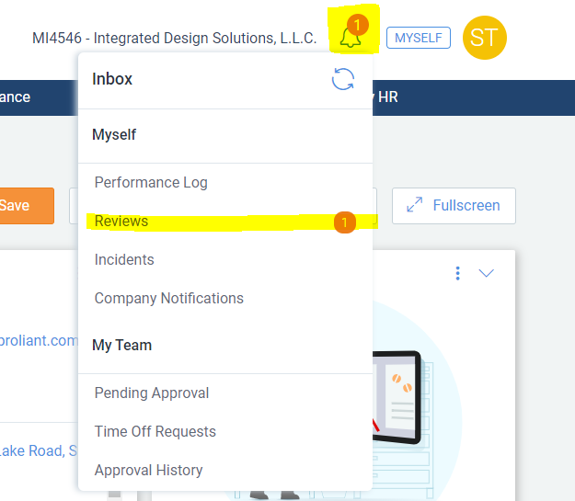
Once you click on reviews it will show you all the reviews you have in progress. You will see the date you have to finish the review as well. To start the review please be sure to click on the Title.
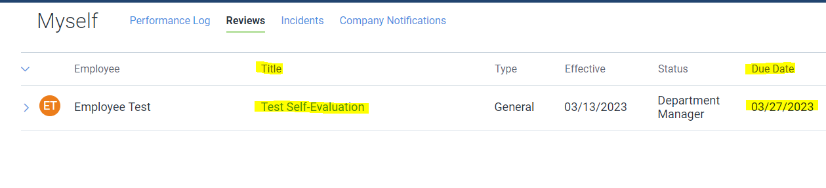
Once you click on the Title of the review, it will bring you to another page.
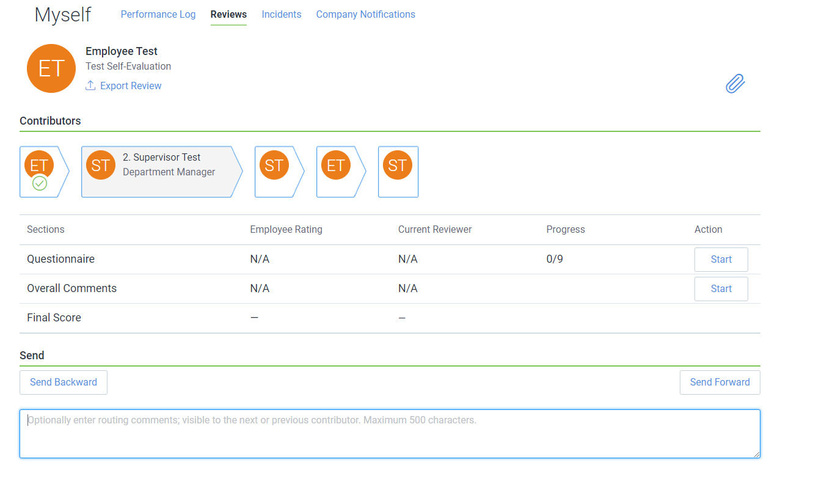
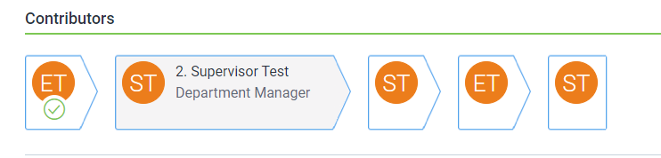
On this page you can see the flow of the review, which just means who the review is going to and when. To see more details about the flow, you can click on the arrows, and it will open up the box with the information.

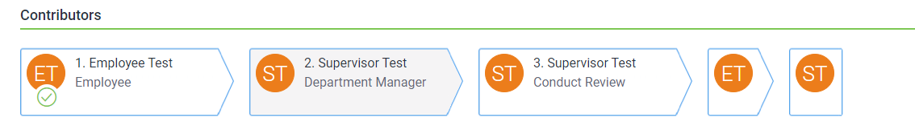

You can also see the number of sections you have to complete and the number of questions in each. As well as how many you have completed out of each section.
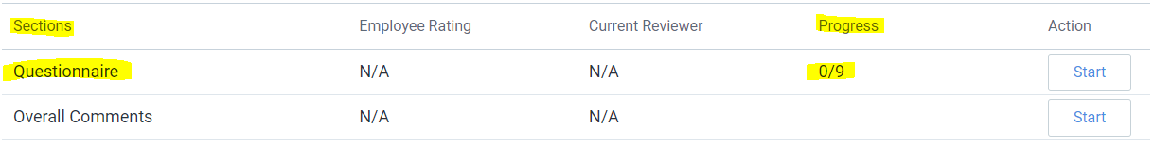
Once you are ready to begin just simply hit the “Start” button in whichever section you want to begin with.
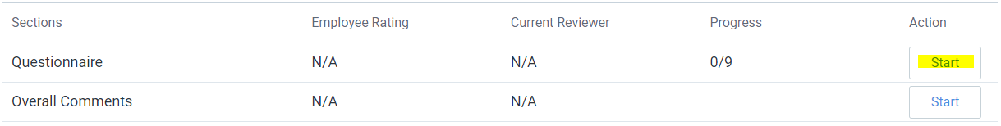
On the Questionnaire section, you can see what all you have to answer on the left side. You will then see under assessment what the question is and what you need to do to answer the question.
You can see what the employee said on this section. The comment section here is optional for you, it’s up to you if you decide to leave a comment. If you do want to leave a comment you would do so in the comment box.
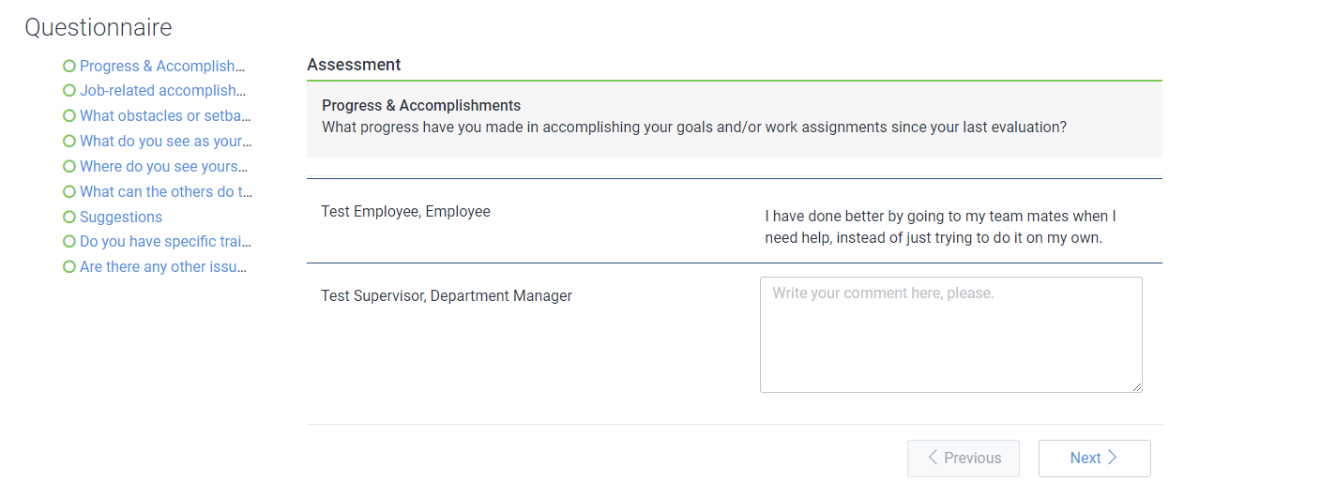

------------------------------------------------------------------------------------------------------------------------------------------Let’s stop here for a moment and talk about the employee section. What happens if maybe the employee writes something they maybe shouldn’t have or you don’t think they gave a good enough answer for one of the questions, what can you do?

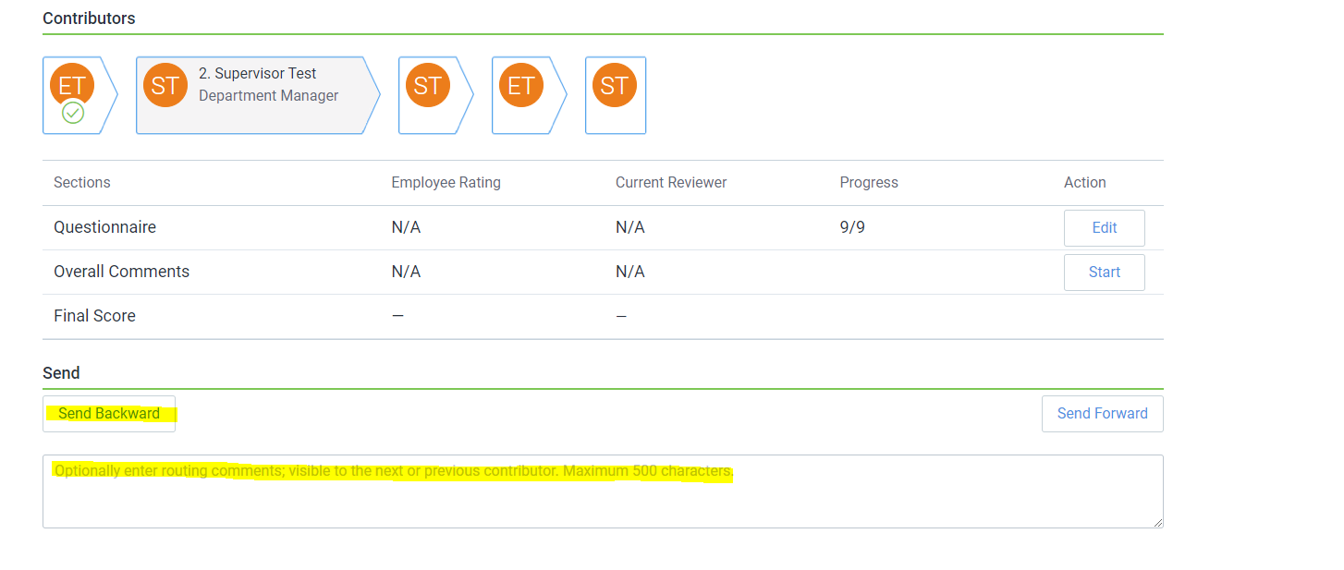
Well, on the summary page at the bottom of the screen there is a send backwards button.

You can click that, and you can leave a comment and tell the employee what needs to be fixed, and it will go back to them to fix. Once they fix it, they will send it back to you and you can finish your section.
------------------------------------------------------------------------------------------------------------------------------------------
Once you go through all the questions and get green checkmarks on all of them you can hit save, it will then take you back out to the summary page. On this page you can see your overall progress.
There is also a section for overall comments, so if you want to leave any extra comments about your review or about anything you can do so by clicking the start button. There is also an Optional routing comments section at the bottom of the page, that is so if you want to leave any comments for the next contributor to your review (In this case that person is you, so there’s no need to leave any routing comments). 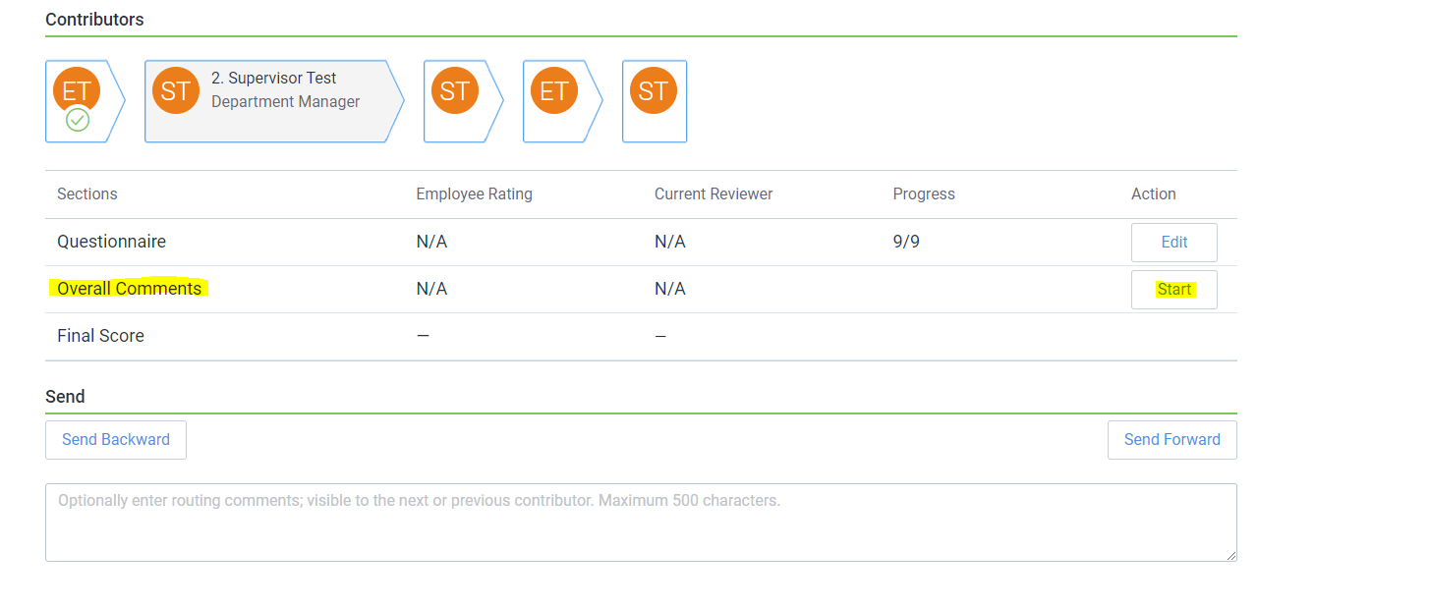
Once you have completed the review and are ready to send it to the next person, you will hit “Send Forward” at the bottom of the page.
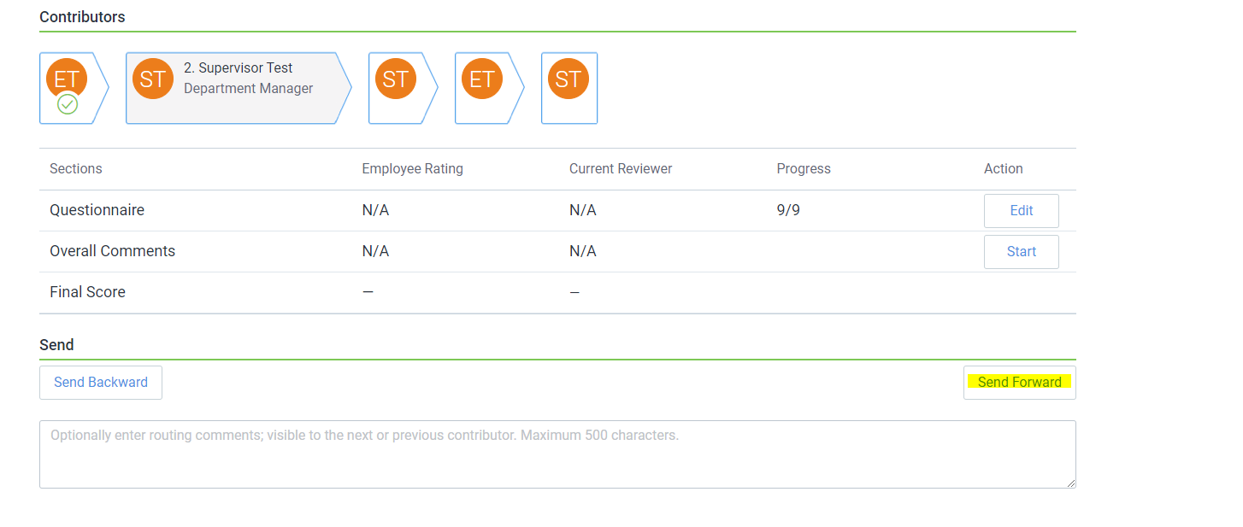
Once you hit send forward you will get a pop up on the page:
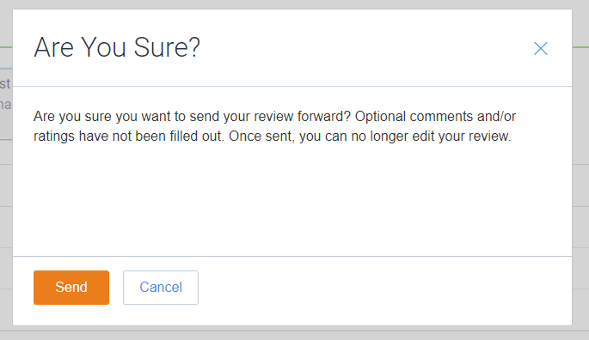 This is saying that even though this information was not required, it is suggested you leave them. It gives you another chance to be sure you are ready to submit the review.
After reviewing the pop up, if you need to do some more work on your review just click “Cancel”, but if you are ready to send it forward, please click “Send”.

Once you hit Send, you will be redirected to the Reviews page, since the next step in the review is the conduct review and you are the one to do that, the review will stay on the Reviews Page, but the Status has changed.
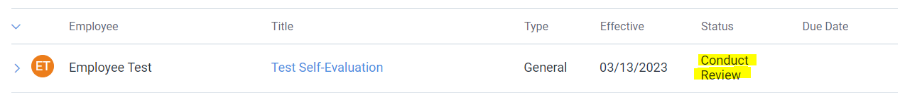

You will also get an email notification:
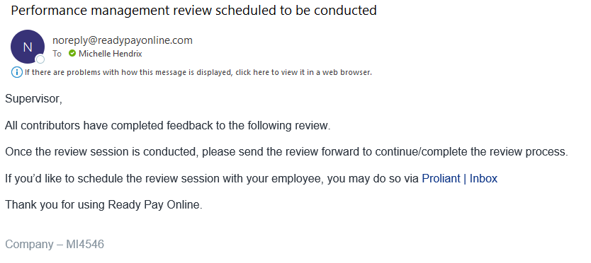
To get back into the review all you have to do is click the title again. This will be what you see now:
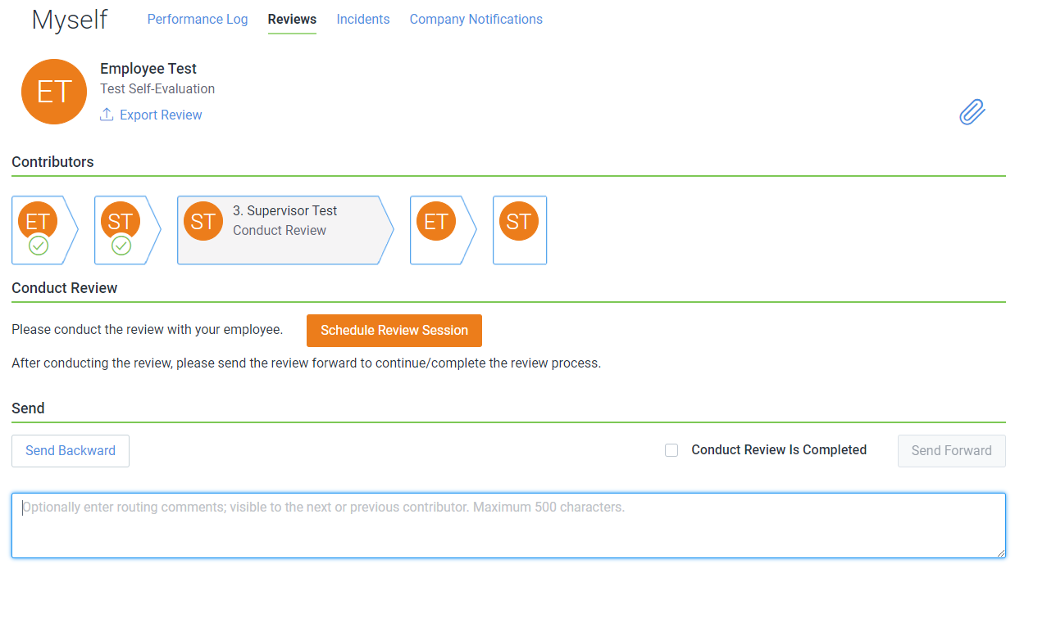

If you want to schedule the review inside here, you can choose the orange “Schedule Review Session” button.
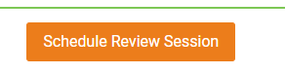 Once you click that button, you will see this:
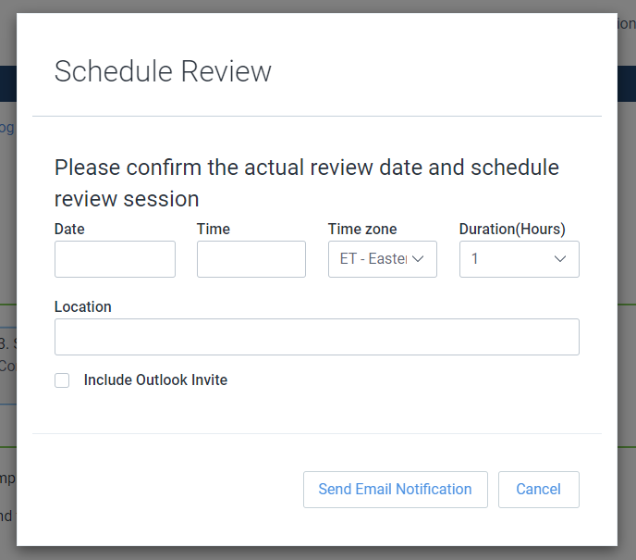
Here you will fill in the information of when you want to schedule it for. You do not have to schedule the review here. This is optional. But to do so when you are done entering in the notification you can click the “Send Email Notification” button at the bottom, and it will send the employee an email notification of the date and time of the review session.
**Please note: The “Include Outlook Invite” does not work at this time, they will get an email notification, but it won’t send an invite to connect to the calendar.**
***Please note: The employee cannot see what answers you have left on the review until after this review has been conducted. You will need to show the employee your answers and ratings during the review, by exporting the review as a pdf. ***
How to export a review as a pdf during the review process:
At the top of the page underneath the name of the review you will see “Export Review”
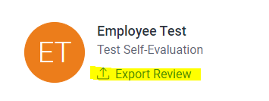

You will click that, and it will download the review into a pdf format for you to be able to save.
***Please Note: The conduct reviews page is the LAST chance you get to send the review back to make ANY changes, once you complete the conduct review step, NO further changes can be made.***
Now once you have completed the review you will need to check off the box on “Conduct Review is Completed.”
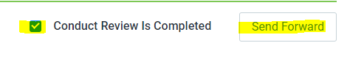
Once you do that then you will hit “Send Forward”. Once you hit Send Forward a box will appear, which will require you to enter the date and time of the review session.
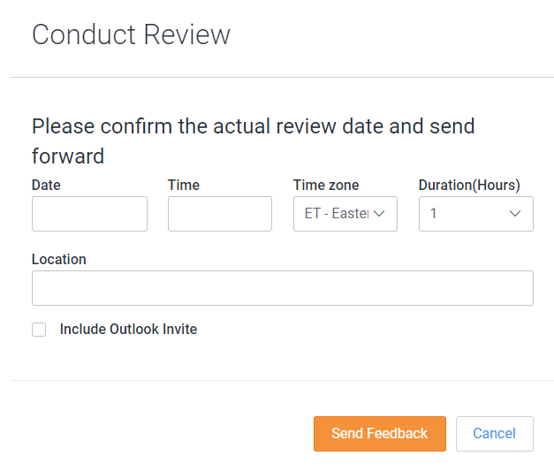
Once you enter the information, you will hit Send Feedback. Once you hit Send Feedback, it will redirect you to the Reviews Page.
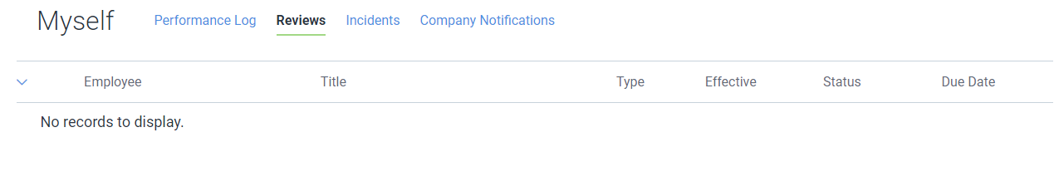It will then send to the employee for a signature, once the employee signs the review, it will then come back to you for a signature.
You will get an email notification telling you that you need to sign the review:
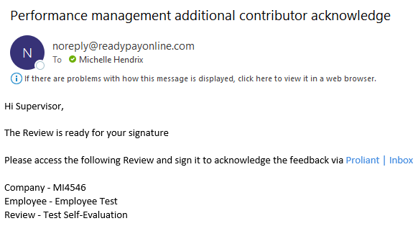
Once you get back into the review, you will see this page:
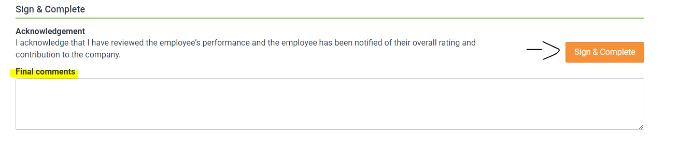
This is where you can write any final comments for the review. For example, if you and the employee talked about something in the review session that you want to write down, this is the place to do that.
Once you make any final comments, if you want, you will then click sign & Complete.
Once you hit that it will pop up a message at the top of the page asking are you sure you want to sign, you will then click OK.
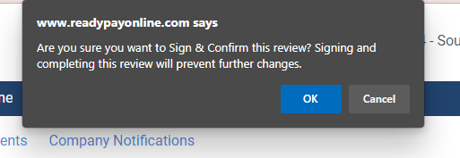
Once you hit OK, it will take you back to the Reviews page. You have now completed the review and can log out!
How to view a review after you have completed it?
You will log into your account and go to the My Performance Tab Review Contributions. Once you are there nothing will show up. You will then toggle the advanced filters tab over to where it is showing the green:
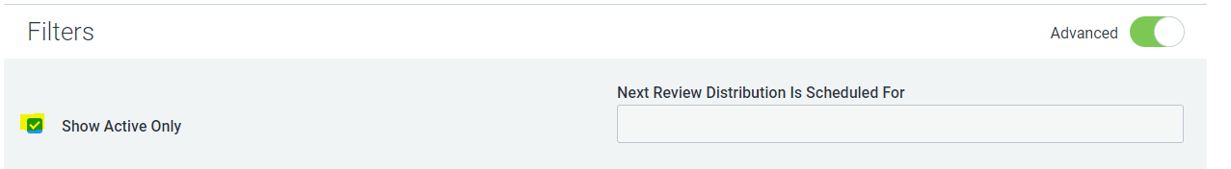
You will then uncheck the Show Active Only box. Once you do that all your reviews you have contributed to will show up.
You can then click on the review title and can view it there, if you want to export it as a PDF, you can click on the Export Review button, and it will download as a pdf.
