You will receive an email notification saying, “A review has been created for you”. There are two ways you can access this review.
The first way is by clicking on the highlighted blue words in the email, you can click on either “Proliant” or “Inbox”, both will take you to the review.
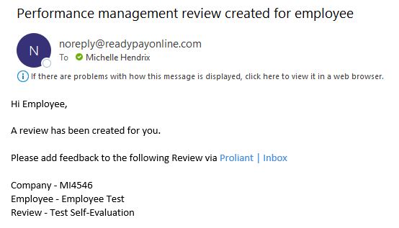
The second way you can access this review would be to log into your account and you will see a bell with a notification on it you can click the bell and click on reviews that way and it will take you to it.
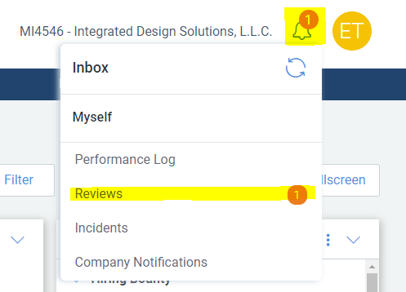

Once you click on reviews it will show you all the reviews you have in progress. You will see the date you have to finish the review as well. To start the review please be sure to click on the Title of the review.
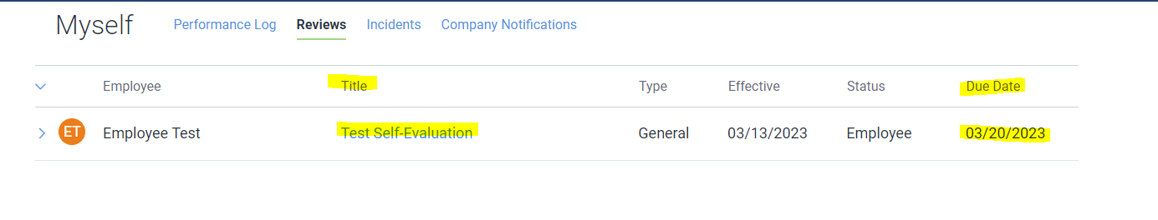
Once you click on the Title of the review, it will bring you to another page.
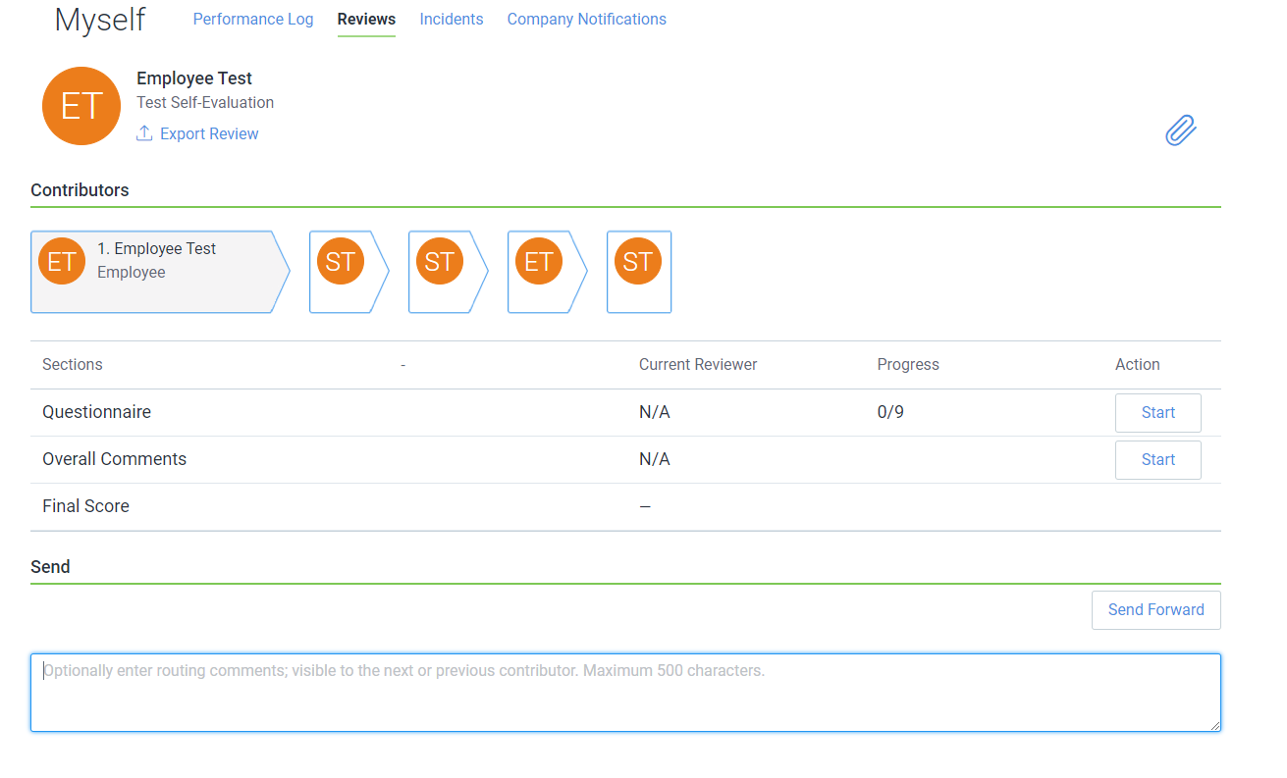
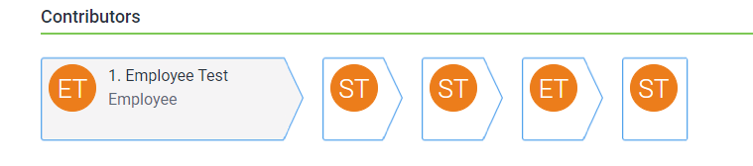
On this page you can see the flow of the review, which just means who the review is going to and when. To see more details about the flow, you can click on the arrows, and it will open up the box with the information.

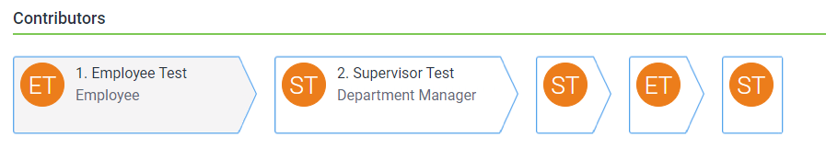

You can also see the number of sections you have to complete and the number of questions in each. As well as how many you have completed out of each section.
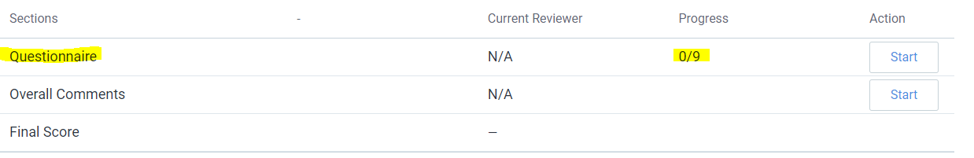
Once you are ready to begin just simply hit the “Start” button in whichever section you want to begin with.
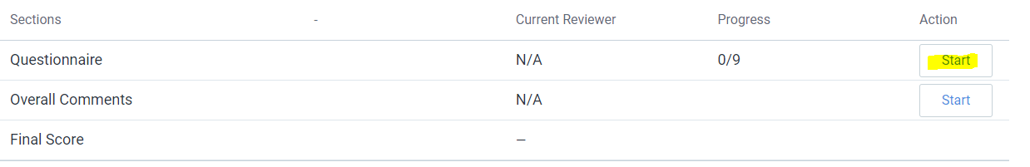
Once you hit start in the Questionnaire section, this is where you will begin answering questions about yourself.
On the Questionnaire section, you can see what all you have to answer on the left side. You will then see under assessment what the question is and what you need to do to answer the question.
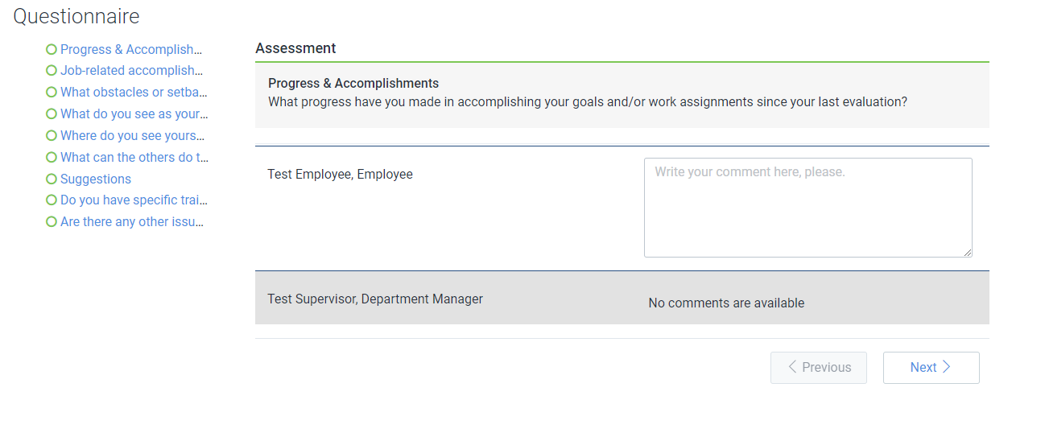

To answer the questions, you will simply type your answer in the comment box. Once you answer the question you will see a green checkmark on the side.
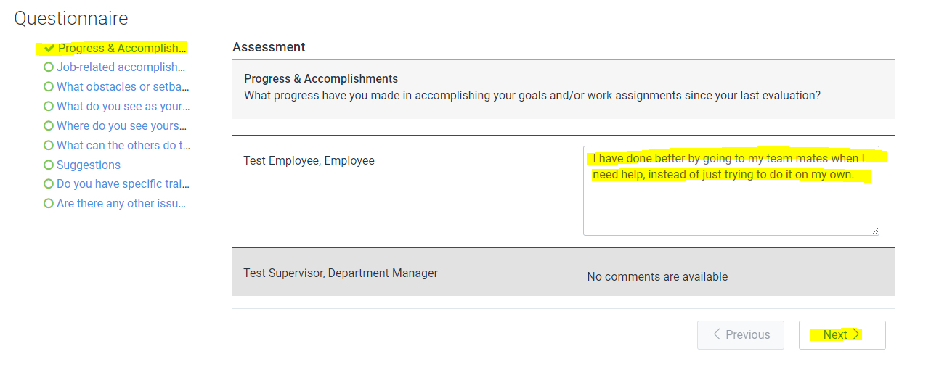
All comments are required for this section, if you do not leave a comment, you will see a red checkmark on the specific question(s) that you did not leave a comment for.
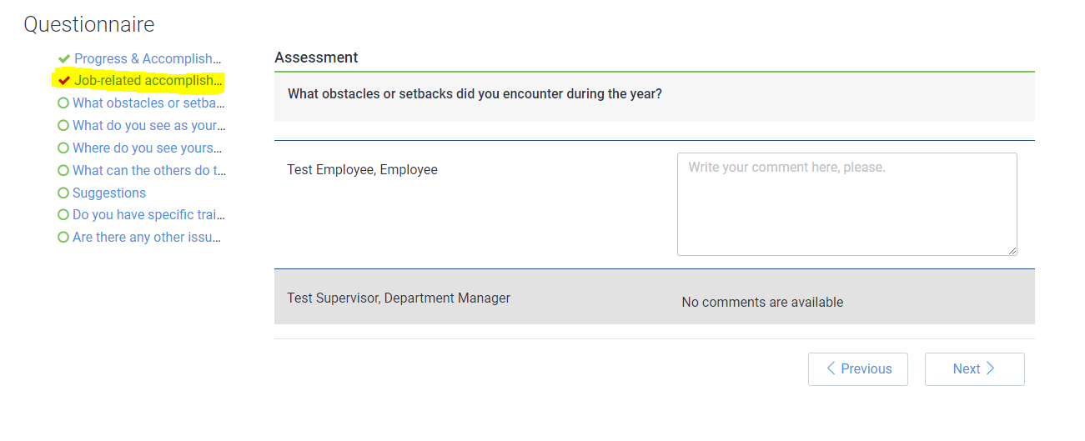
As you can see the 2nd questionnaire “Job Related Accomplishments…” has a red checkmark on it, and you can see I am on “What obstacles or setbacks...” now. Which means I did not rate myself for the 2nd questionnaire and moved on to the 3rd one.
Once you do finish all the questionnaire questions you can see to the left if they are all finished or not. Once you are finished you can click save at the bottom. 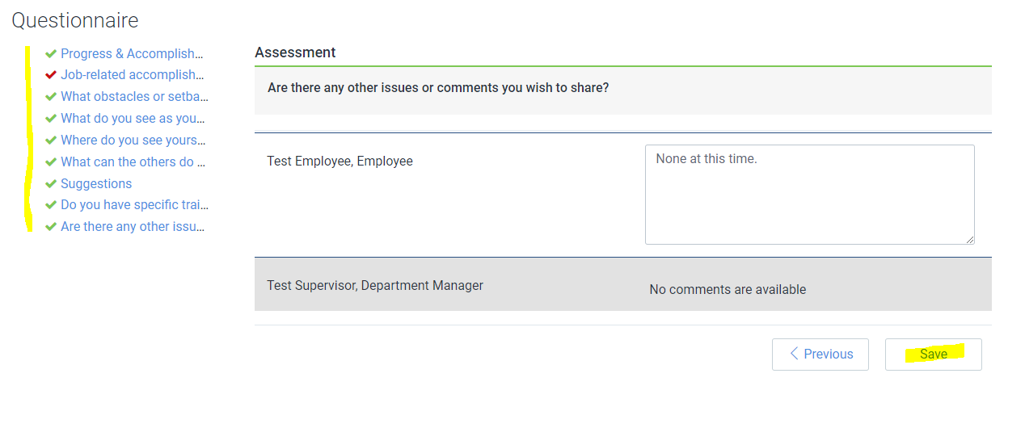
Let’s say for the sake of this example you do not notice that you have a red checkmark and go ahead and click save. Once you click save it will take you back to the review page. You can see here your progress, and on that progress, it shows you are missing one, with an 8/9. You will need to click resume and finish the questionnaire you missed. Once you click on resume it will take you directly to the missed question.

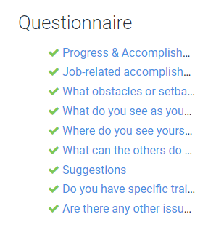
Once you go back in and complete it, you can see that you now have all green checkmarks.

Then once you click save, it takes you back out and you can see your final progress for the questionnaire section, and the action button also says edit instead of start or resume.
There is also a section for overall comments, so if you want to leave any extra comments about your review or about anything you can do so by clicking the start button. There is also an Optional routing comments section at the bottom of the page, that is so if you want to leave any comments for the next contributor to your review.
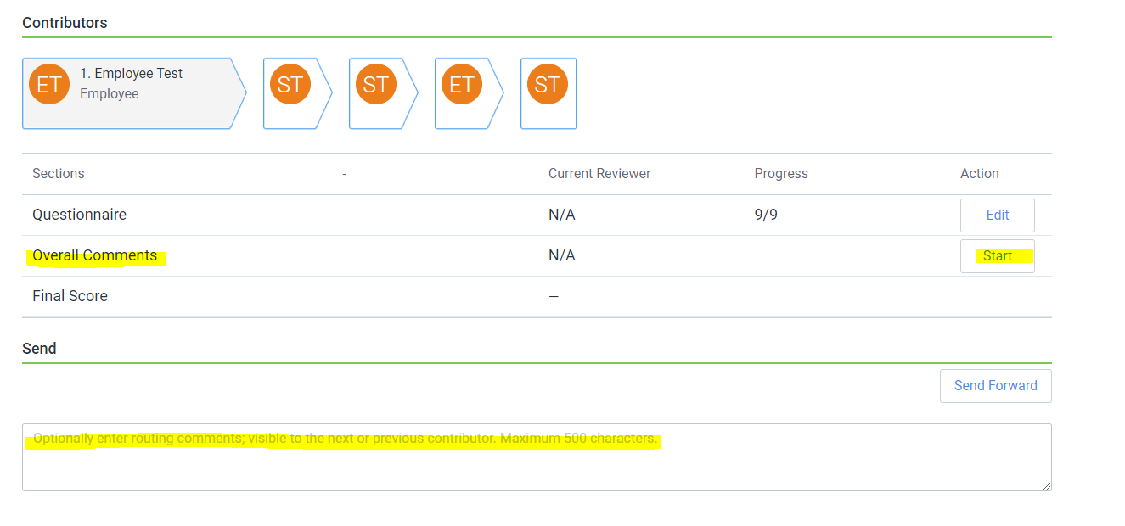
Once you have completed the review and are ready to send it to the next person, you will hit “Send Forward” at the bottom of the page.
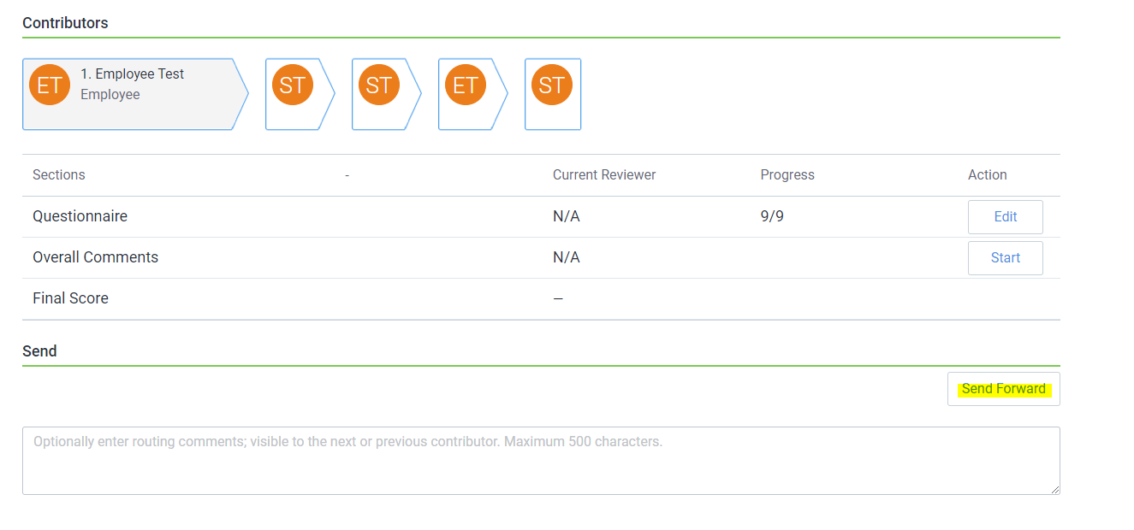
Once you hit send forward you will get a pop up on the page:
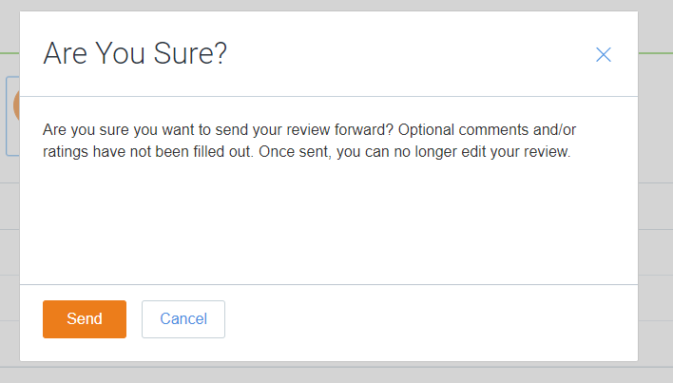
This is saying that even though this information was not required, it is suggested you leave them. It gives you another chance to be sure you are ready to submit the review.
After reviewing the pop up, if you need to do some more work on your review just click “Cancel”, but if you are ready to send it forward, please click “Send”.
Once you hit “Send” you will be redirected to the Reviews page, you are now free to log out.
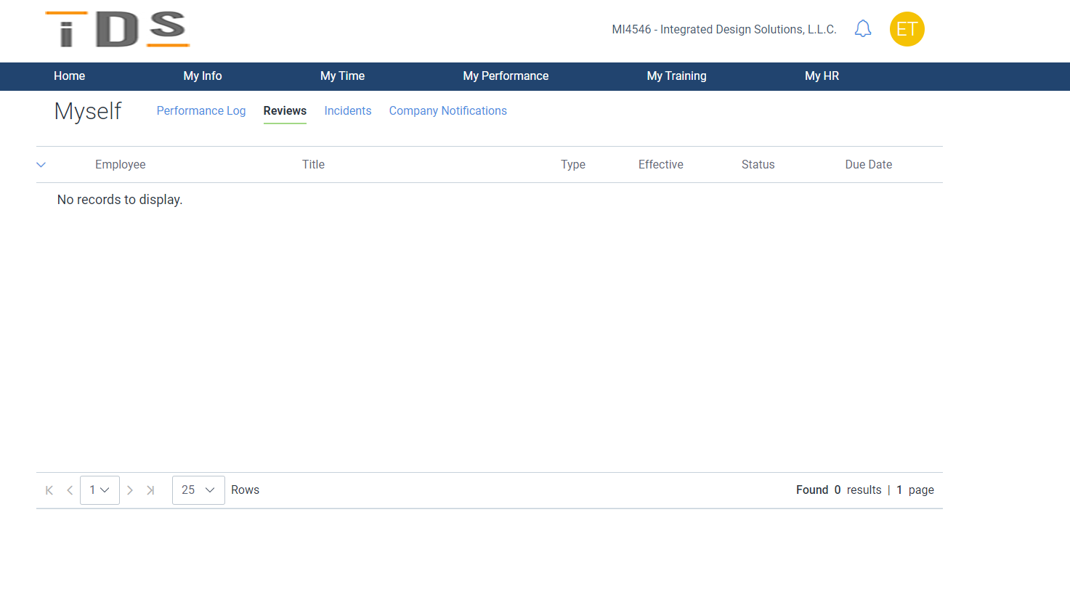

After you send the review forward. It will then go to your supervisor for review. They will then reach out to schedule a conduct review with you to go over the review. After you have the conduct review the manger will then send the review back to you for a signature.
You will get an email notification telling you that you need to sign the review:
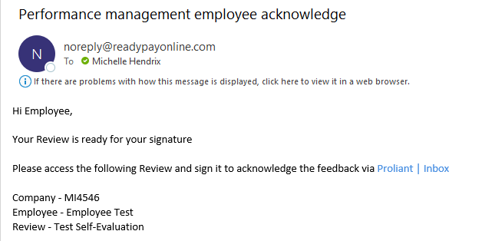
Once you get back into the review, you will see this page:
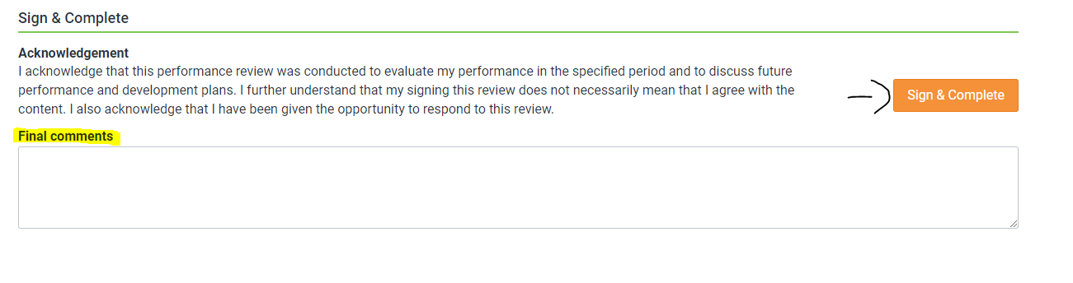This is where you can write any final comments for the review. For example, if you and the manager talked about something in the review session that you want to write down, this is the place to do that.
Once you make any final comments, if you want, you will then click sign & Complete.
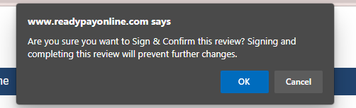
Once you hit that it will pop up a message at the top of the page asking are you sure you want to sign, you will then click OK.

Once you hit OK, it will take you back to the Reviews page. You have now completed the review and can log out!
After the review is fully complete, you will get an email notification letting you know.
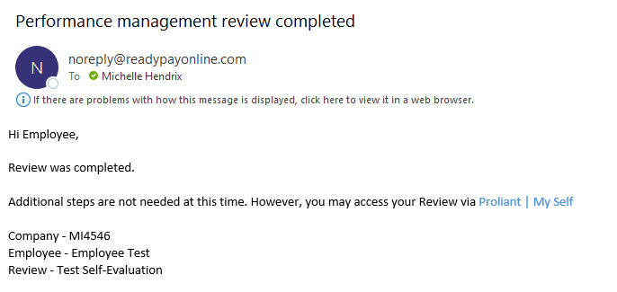
How to view a review after you have completed it?
You will log into your account and go to the My Performance Tab My Reviews. Once you are there nothing will show up. You will then toggle the advanced filters tab over to where it is showing the green:
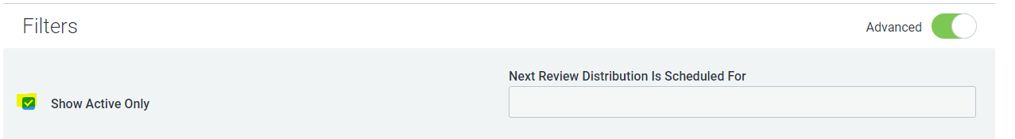
You will then uncheck the Show Active Only box. Once you do that all your reviews you have completed will show up.
You can then click on the review title and can view it there, if you want to export it as a PDF, you can click on the Export Review button, and it will download as a pdf.
